The below document covers the 3 scenarios-
- Connecting the Agent to the Jira
- Extracting all the userstories from jira in dropdown and select
- Create feature file for the userstory selected

Screenshots
- Connect to Jira account and fetch the userstories loaded
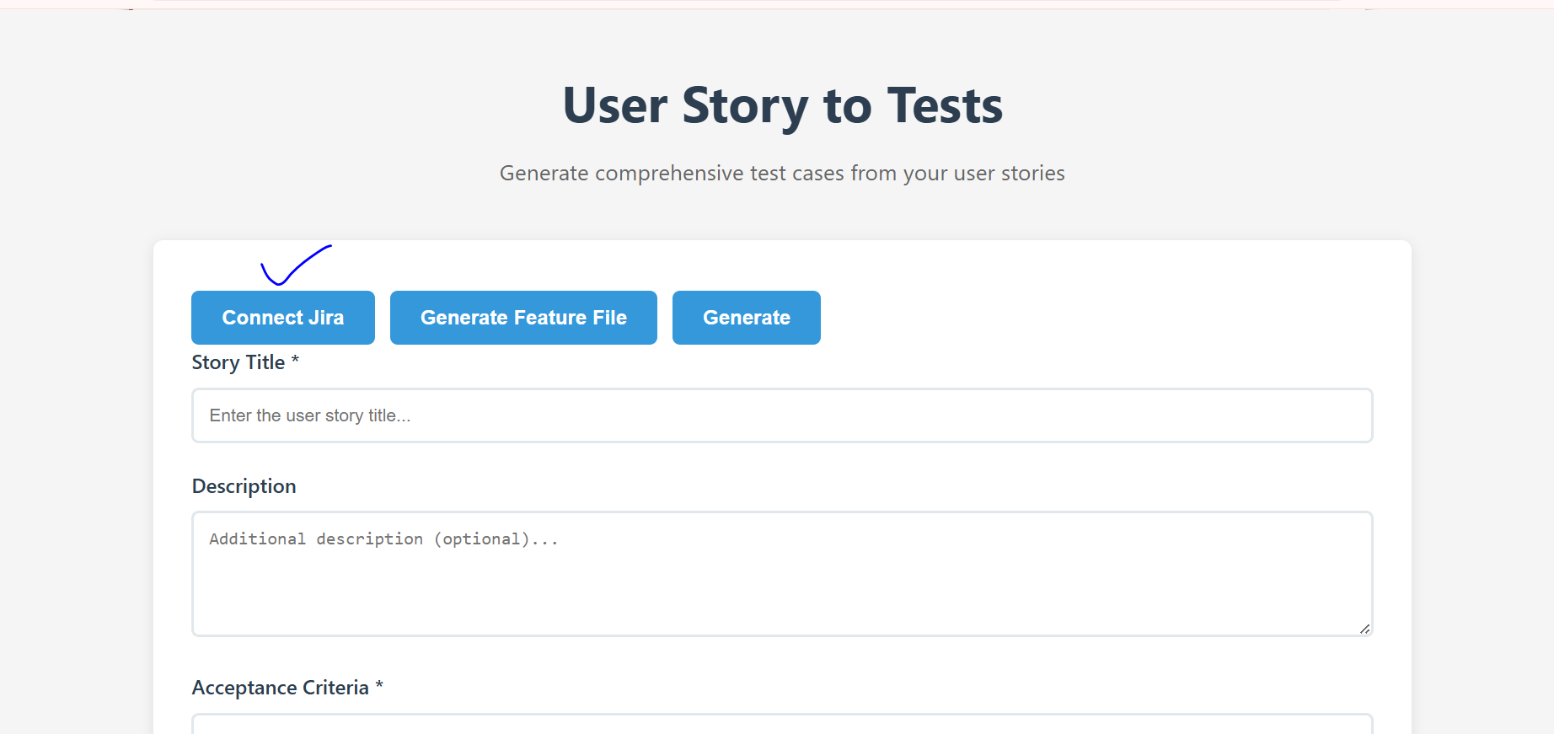

2)Click on connect Jira

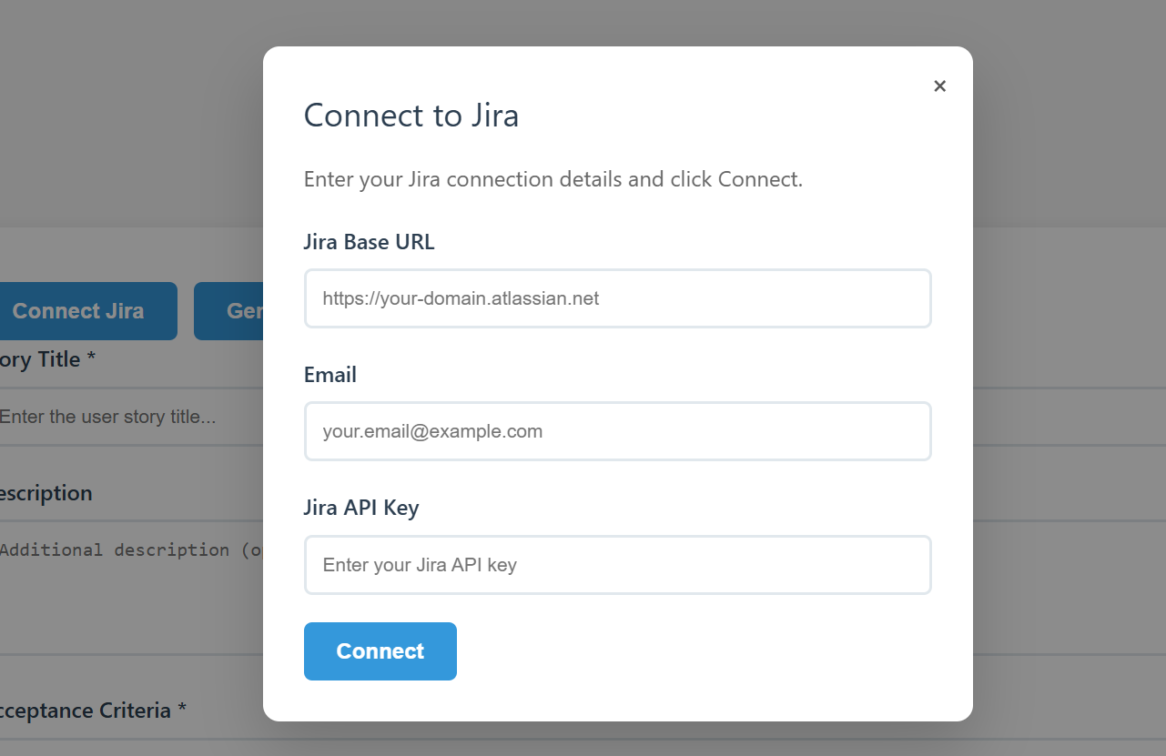

3)Once the details are filled the user stories drop down is displayed
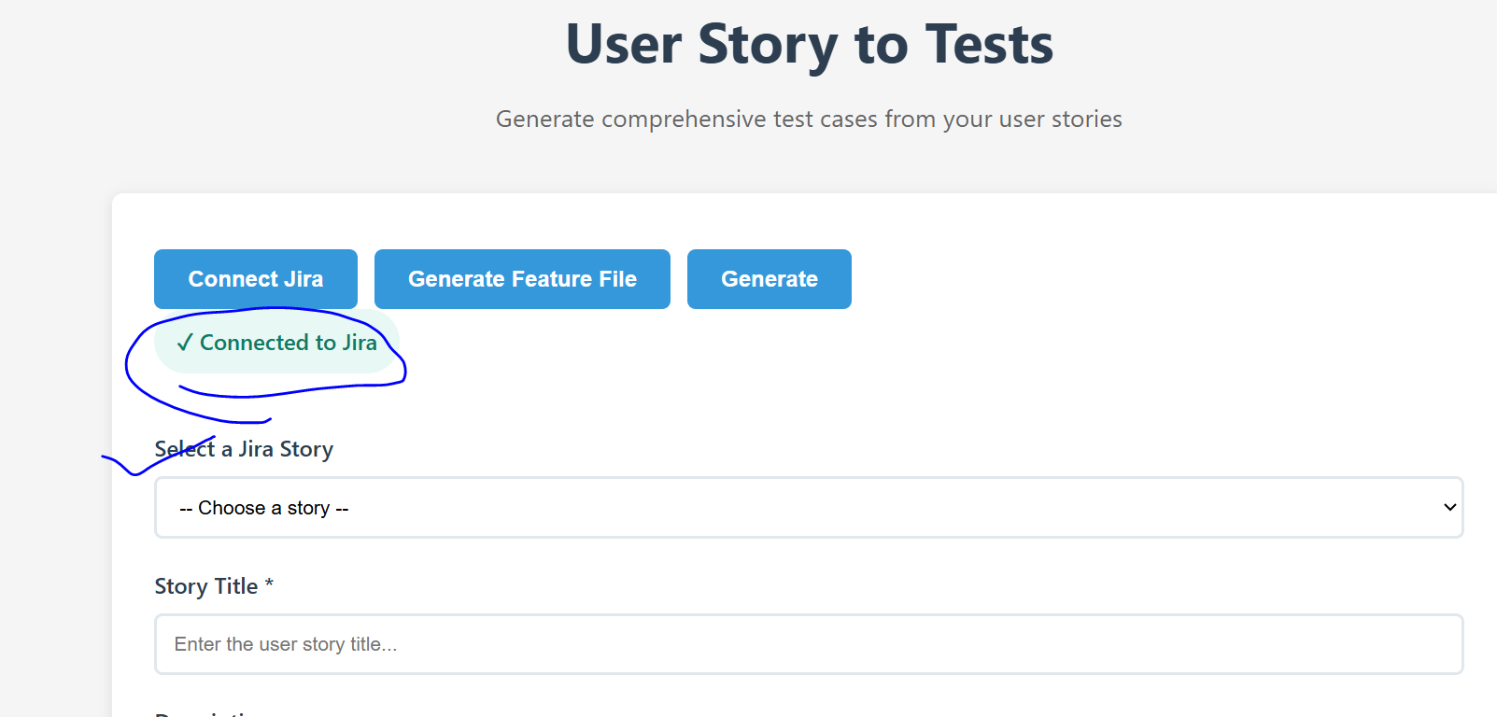

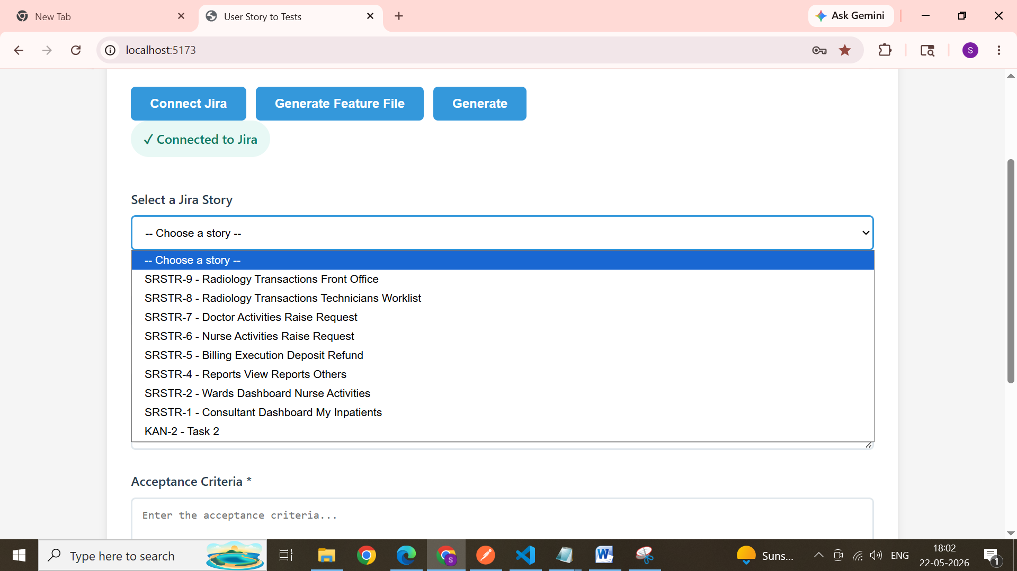

4) Select a userstory and see it is auto filled in story section
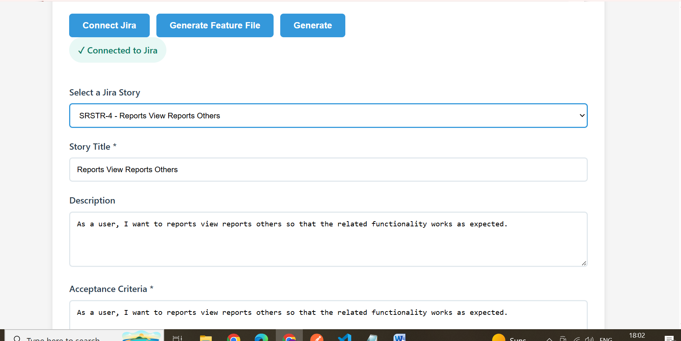

5) click on generate button to generate the test cases related to it
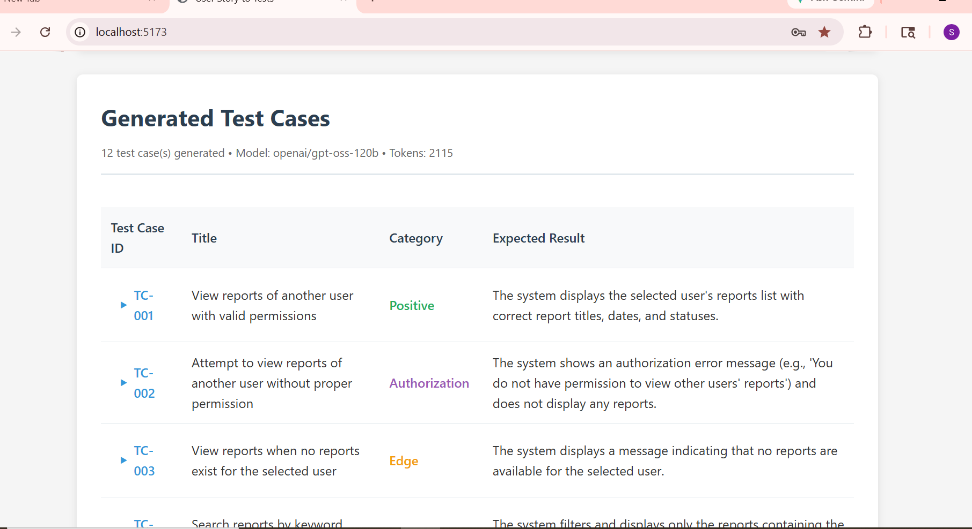

6) click on feature file option to generate the feature file for the selected story
